PRN NO:- 220940520044

NAME:- Kaustubh Pandit Kasote

1) Open the url

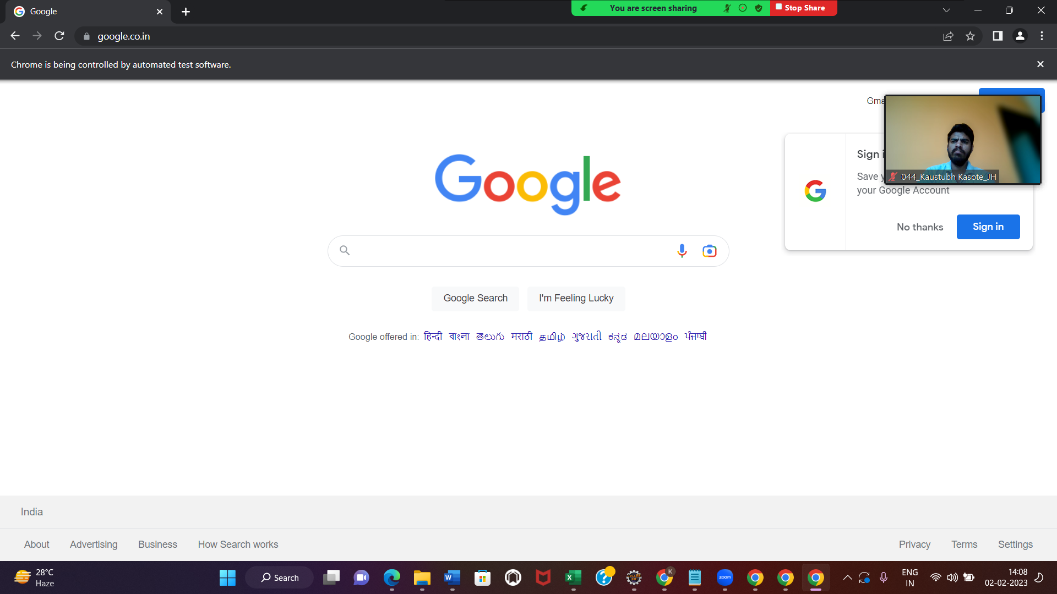

2) Go to SignIn

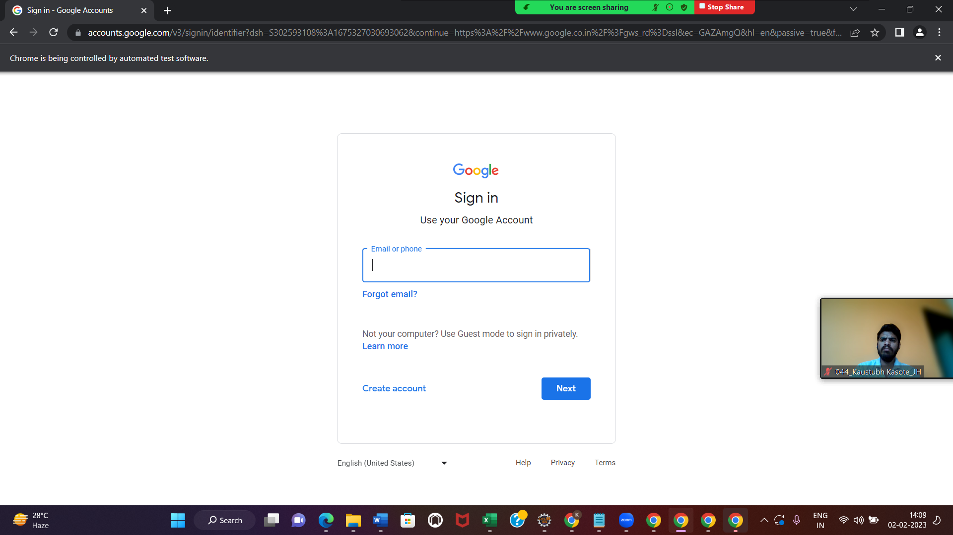

4)click on google apps

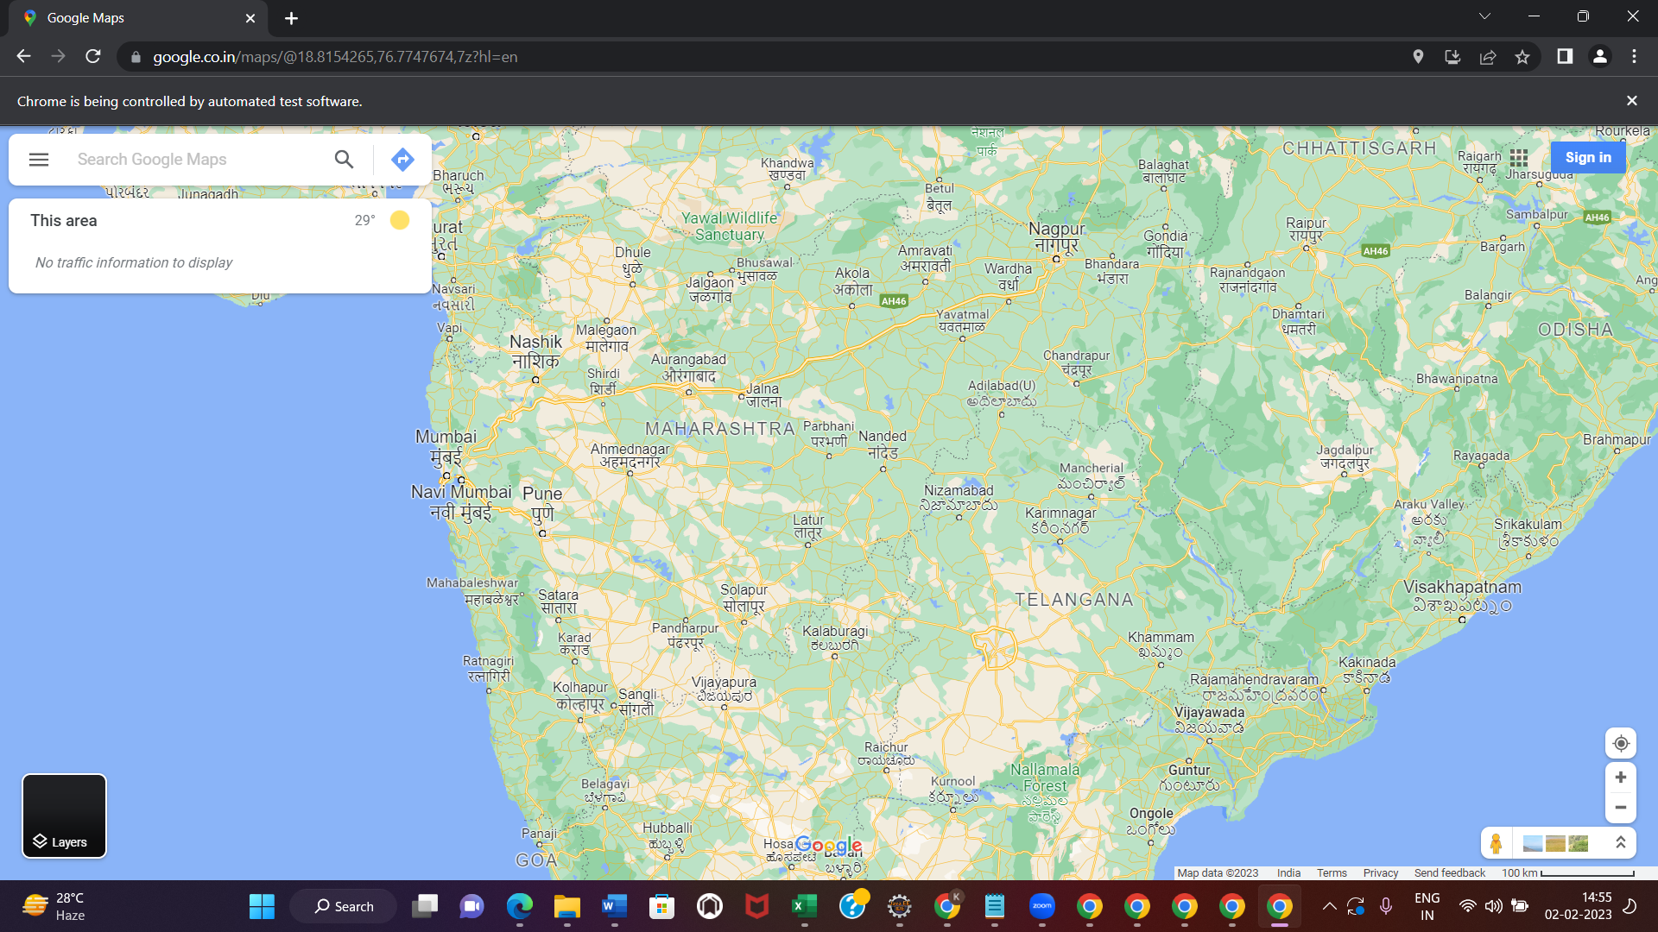

5)search for CDAC

